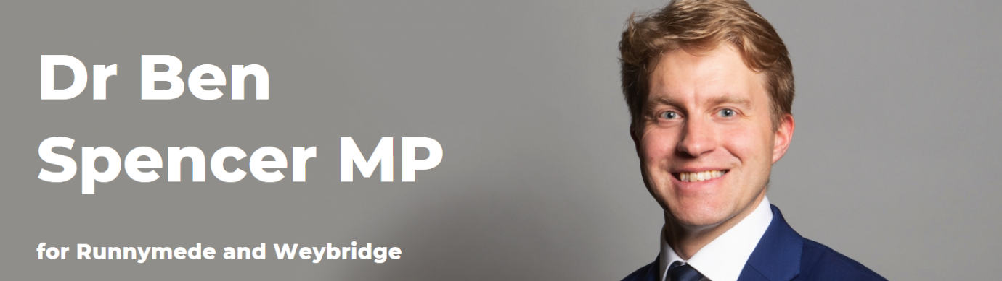

Planned aviation debate speech, 10 September 2020

Thank you Mr Speaker.
I’d like to start by thanking my honourable friend, the member for Bexhill and Battle, and the backbench business committee for securing this debate. Covid is here and we must be realistic – without a vaccine and perhaps even with one – covid is not going to go away
In true British spirit, all across our societies and our communities we have risen to the challenge, and adapted and flourished. But the aviation sector still faces extreme turbulence, most planes are grounded, and with them a huge chunk of our economy, and all the jobs and businesses that depend on them.
Runnymede and Weybridge prospers through our connectivity nationally and internationally through our motorways and our proximity to Heathrow and London. We need to get the industry off the ground, and soon. Across the channel our European competitors are cracking on, implementing testing, and gearing up to take on Global Britain. How can we have a global Britain without global connections?
Our Aviation industry is dominant in Europe – but if its prime position is lost – we may never get it back. The challenge we face is not just saving jobs today, but jobs for our children too.
There are many topics I could cover in this debate, including financial support, sustainability, the actions of specific carriers such as BA, but due to the limited time I have I must prioritise the area that I think can elicit most change. If we cannot increase demand and get our planes back in the air – it’s all over. And the main barrier to that is the blanket 14 day quarantine currently acting as a backstop. And we know how aversive backstops are.
I know that the Government and ministers have done a huge amount to break the quarantine backstop, with the opening of air corridors. But to rebuild we need long term solutions that can provide stability and confidence needed for growth. So I would ask them to stretch their sinews just a little further and bring in testing and negotiate international safety standards.
The Government is committed to following the science, so I will talk about the science.
The prime minister, and the Secretary of State for Transport have quoted stats saying that if we brought in airport testing, it would only pick up 7% of cases of people with coronavirus. This comes from the SAGE paper – ‘investigation into the effectiveness of “double testing” travellers incoming to the UK for signs of COVID-19 infection’ published in June this year.
This is a great paper which presents a range of models of testing options. The first option is testing only on arrival which yes indeed picks up only 7 out of 100 cases.

Members may ask - why is the rate so low? Well the ability of our Covid PCR tests to detect illness depends on how long you have been incubating it for and linked. If someone with covid sneezes on you, you may be brewing covid, but you won’t test positive until several days or more after. As the virus takes time to multiply in order to be detectable. So to use testing for asymptomatic screening – as we would be with airport testing –time is needed to allow for incubation.
So there is another option in this paper, which involves testing after 5 days of quarantine, with a further 2 days quarantine. This picks up 85 out of 100 cases. This would halve the time to quarantine – and roll back some of the crippling pressure on the aviation sector.
Is picking up 85 out of 100 cases from an airport screening and quarantine good enough? There is a straw man argument being circulated that screening has to be perfect, that unless every case is detected it is without value. Nothing is perfect.
Picking up 85 out of 100 cases – is a similar ballpark figure to the performance of our domestic testing that we use when people manifest symptoms. We cannot live in a society without risk, and screening is about risk reduction – not risk elimination – and remember economic damage by grounding planes is not without risk as poverty and socioeconomic deprivation kill just as effectively as any coronavirus.
No medical screening programme such as any of our cancer screening programmes pick up every case.
Now – I must say to the House the science of population screening is far more complex than I have laid out as factors such as the underlying prevalence of the illness and others are important. In this paper, SAGE of course points this out – and refers to a companion piece that takes into account individual country prevalence – has this been completed and can it be published?
Mr Speaker. Scientists advise, ministers decide – the science is clear, testing as I have outlined could halve quarantine and help people not only return to work sooner, but also provide much needed certainty for passengers and the aviation sector.
Will my honourable friend follow the science and bring in testing?

